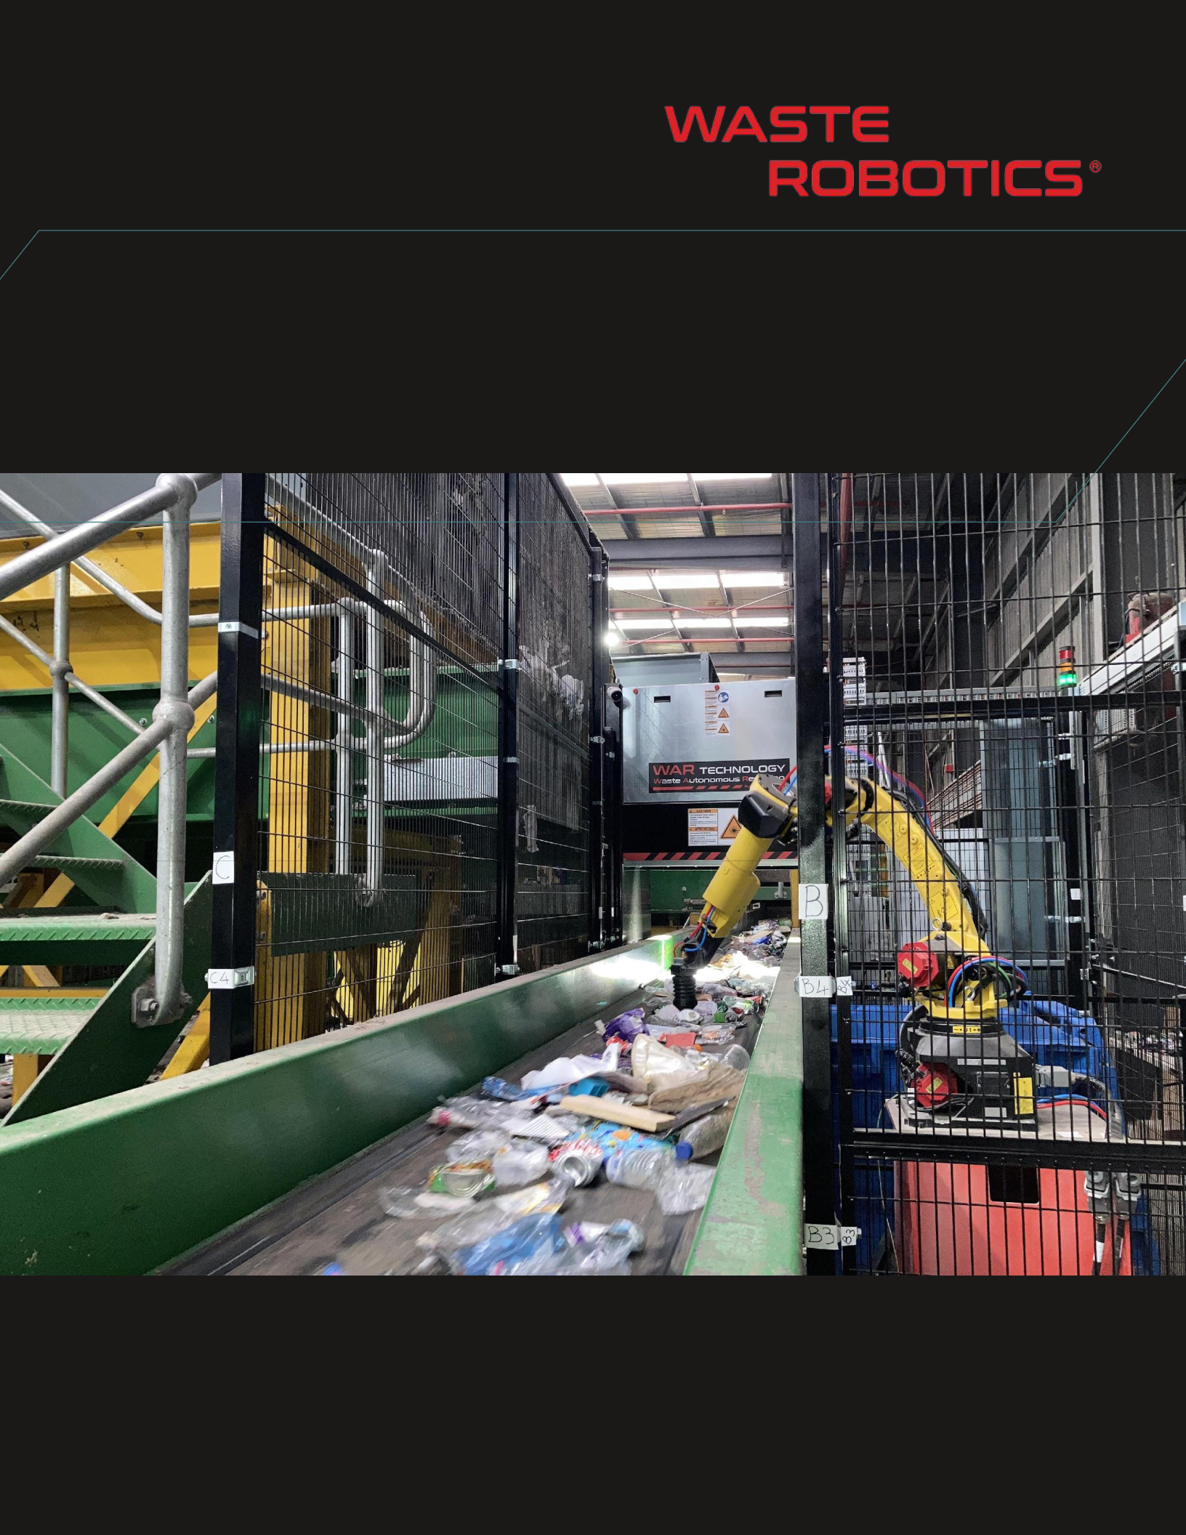

VALUE PROPOSITION:

Test Number One Million

|  |  |  |
| --- | --- | --- |
| **Presented to: client** | July 03, 2025 | |
| **sunshine enterprises** |  |  |
|  | CONFIDENTIAL | |

**APPLICATION OVERVIEW**

inj

**PRELIMINARY LAYOUT DESIGN (1-ARM SYSTEM)**

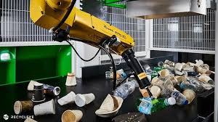



CONFIDENTIAL – PAGE 3/7

**LAYOUT OVERVIEW (1-ARM SYSTEM)**

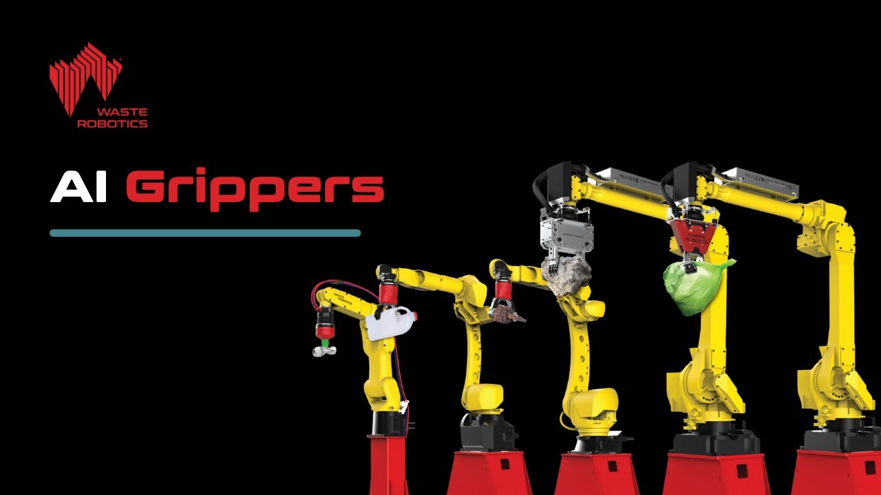





CONFIDENTIAL – PAGE 4/7

**ROBOT ARMS MODEL**

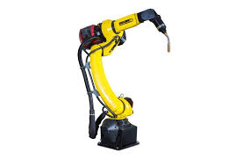

**GRIPPER MODEL: VentuR**

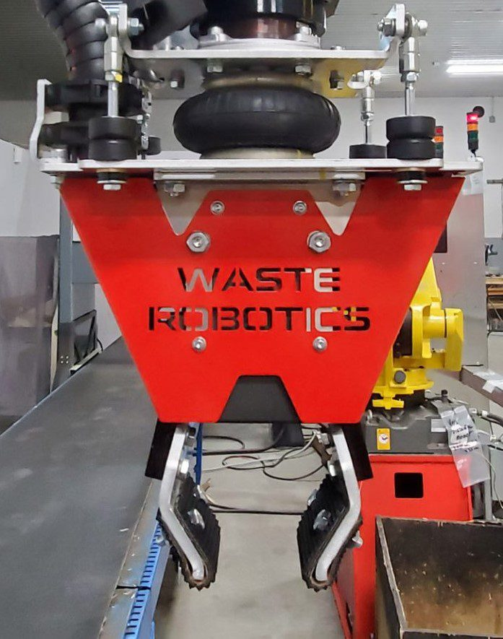



CONFIDENTIAL – PAGE 5/8



**ROBOT VISION SYSTEM SENSOR FUSION**

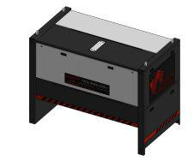

**Deepvision**

**COLOR** **3D** **AI**

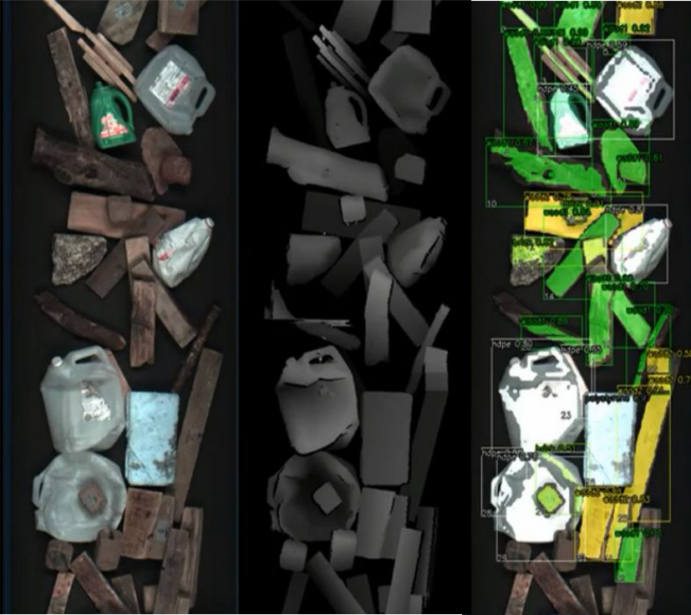

CONFIDENTIAL – PAGE 6/8

**SPECIFICATIONS:**

* Up to 35 picks/min
* Maximum object weight per robot: 24.0 kg
  + Robots operating conditions: 5°C to 45 °C

**BUDGET**



|  |  |  |  |  |
| --- | --- | --- | --- | --- |
|  | **Includes** |  | **Excludes** |  |
| - 1 robots Fanuc M-20iD-25 | | - | Mechanical installation |  |
|  |  |  |
| - | 1 robot base | - | All modifications required on current equipment to integ |  |
| - | 1 AI gripper | the robotic system | |  |
| - Robot Vision System: DeepVision System) | | - Electrical hookup in client’s facility | |  |
| - | AI Software licence | - Total input power 24.0 kVA | |  |
| - | AI custom training | - Average Power Consumption 42.0 kW | |  |
| - Factory pre-assembling and testing | | - Internet hookup in client’s facility | |  |
| - | Shipping to Massachusetts |  | (up/down 100 Mbits/sec) |  |
| - Installation supervision on site | | - Compressed air hookup in client’ facility | |  |
| - | Security perimeter |  | (total air consumption: 24 L/min |  |
|  |  | - Taxes, customs and/or duty charges | |  |

**BUYING PRICE\***

Robotic sorting system:

USD 429,049

Additional robot arm:

*\* Prices may vary due to exchange rates, inflation, and integration engineering. Valid for 30 days.*



CONFIDENTIAL – PAGE 7/8

**DELIVERY**

24-30 weeks (to be confirmed at order time)